**NEWSLETTER SEPTEMBER 2024**

**PRESIDENT’S REPORT:**

The Banyule Seniors Festival in October offers mostly FREE or low-cost events. Watsonia 50s Plus is hosting eight events during Seniors Month:

* Tai Chi Qigong: Monday, 7 October at 10:00 am
* Cards 500 & Canasta: Thursday 10 October, 12 pm
* Aerobics: Thursday, 10 October at 10:00 am
* Gentle Aerobics: Thursday, 10 October at 10:45 am
* Indoor Carpet Bowls, Thursday 10 October at 1:00 pm
* Scrabble: Wednesday, 9 October at 1:00 pm
* Tai Chi: Thursday, 17 October at 9:00 am
* Old Time Dance: Sunday, 20 October at 1:30 pm

The Watsonia 50s Plus Club Inc has three Tai Chi instructors. Nina, a certified Tai Chi Instructor for Arthritis and Falls Prevention, and has also completed a workshop on the 24 Forms (Yang Style), one of the most popular Tai Chi forms.

Here is some information about the “Tai Chi for Arthritis Program”. Over ten studies have shown it relieves pain, maintains and improves health and the quality of life. Because of this, arthritis organisations, including the Arthritis Foundation in USA and Australia, Arthritis Care of UK, and Osteoporosis Australia support this program.

**Tai Chi for Arthritis Program:**

* Teaches “Sun Style” which is effective and easy to learn
* Can be practised sitting as well as standing. Almost anyone (of any physical

condition) can begin and continue to progress regardless of age.

* Incorporates exercises that improves muscular strength, flexibility and fitness.
* Focuses on weight transference, which improves balance and thus prevent falls.

For now, Nina is incorporating some Tai Chi for Arthritis in her Monday morning class. After the school holidays, with enough interest, a new class will be added on Wednesday mornings at 10:00 am.

**Northern Indoor Carpet Bowls Tournament:**

The Northern Indoor Carpet Bowls Tournament is on Thursday, 28 November 2024 - 9:00 am to 3:30 pm at the Thomastown Recreation and Aquatic Centre, Main Street, Thomastown.

**Dennis Richards**

**Treasurer’s Report:**

|  |  |  |  |  |
| --- | --- | --- | --- | --- |
| **WATSONIA 50s PLUS CLUB** | | | |  |
| **ACCOUNTS FOR MONTH OF AUGUST 2024** | | | | |
|  |  |  |  |  |
| **Bank Balance as at 1 August 2024** | | | | **$ 19,821.18** |
| **Add - Cash Received** | | |  |  |
| Bank Interest | |  | $ 0.17 |  |
| Membership Money | |  | $ 80.00 |  |
| Aerobics |  |  | $ 1,092.00 |  |
| Gold Coin Collection | |  | $ 279.10 |  |
| Mystery Trip | |  | $ 210.00 |  |
| Werribee Mansion Day trip | | | $ 960.00 |  |
| Arthur Seat Day trip | |  | $ 1,635.00 |  |
| 5 Day Trip |  |  | $ 2,465.00 |  |
| Raffle Ticket Money | |  | $ 129.00 |  |
| Sister Act Show Money | | | $ 280.00 | $ 7,130.27 |
|  |  |  |  | 26951.45 |
| **Less - Expenditure** | |  |  |  |
| Travel Expenses | |  | $ 50.00 |  |
| Hall Booking Fees | |  | $ 397.50 |  |
| Tea Expenses | |  | $ 198.75 |  |
| Werribee Trip Expenses | | | $ 779.15 |  |
| Aerobics |  |  | $ 750.00 |  |
| Refunds |  |  | $ 140.00 |  |
| Bus Fare (Werribee Mansion) | | | $ 1,210.00 | $ 3,525.40 |
| **BANK BALANCE AS AT 31 AUGUST 2024** | | | | **$ 23,426.05** |

**Anura Wijekoon**

**Club Badges:**

Club badges are now available with the Club’s logo and your name.

Badge with a magnet - $10.00

Badge with a clip - $10.00

When placing your order, please print your name on an envelope and type of badge you would prefer, with money enclosed, and place in the letter box on the notice board in the hall.

**The Current Committee:**

|  |  |  |
| --- | --- | --- |
| **Executive:** | **Role:** | **Contact Details:** |
| Dennis Richards | President  Bowls Coordinator | 0447 575 098  dr2232@gmail.com |
| Lynne Moore | Vice President | 9435 8749  lynnejim1@bigpond.com |
| Barbara Pike | Administrative Secretary  Public Officer | 0419 579 954  bandrpike@gmail.com |
| Anura Wijekoon | Treasurer | 0417 054 229  awijekoo@bigpond.net.au |
| Mary Ann Williams | Membership Secretary, Tours and Special Events,  Technology |  |
| **General Committee Members** | | |
| Liz Triance | Day Trips | 0402 047 665  trianceliz@gmail.com |
| Margaret Porritt | Theatre | 0409 857 884  porittmargaret@gmail.com |
| Jackie Edwards | Newsletter | 0422 067 334  jedwards100@hotmail.com |
| Lynne Kearney | Cards | 0400 154 002  lynjk1@bigpond.com |
| Brenda Spessott | Welfare Officer | 0434 949 812  [leo2740@bigpond.com](mailto:leo2740@bigpond.com) |
| Robyn Fulton | Banyule Council Representative | 0413 028 276  fultonrobyn@hotmail.com |
| Sue Rumney | First Aid Kit Maintenance | 0409 132 153  susie_021@hotmail.com |

**IT Support – Thursday afternoon at 2pm**

**Please contact Mary Ann** on 0412356465 or email [info@watsonia50splusclub.com](mailto:info@watsonia50splusclub.com) and book a session.

**Mary Ann Williams**

**Membership:**

Currently, we have 189 members and a very high rate of participation in Club activities and outings.

**Mary Ann Williams**

**Welfare Report:**

A card has been forwarded to Mick O’Brien who is currently unwell to let him know we are all thinking of him at this time.

**Brenda Spessott**

**Sister Act – Regent Theatre Matinee**

**WEDNESDAY AFTERNOON 4 DECEMBER 2024 AT 1PM**



**Members $70.00 Non-Members $75.00**

|  |  |
| --- | --- |
| **Depart:** | Watsonia/Greensborough Train Station |
| **Payment due:** | 4 October 2024  Preferably by bank transfer payment  Watsonia 50 Plus Club |
| **Direct Payment Details:** | **BSB: 633 000**  **Account No : 162498554**  **Ref: (INCLUDE YOUR NAME AND SISTER ACT)** |
| **Non-Members:** | Please email your name and telephone number so we can contact you in an emergency to:  [info@watsonia50splusclub.com](mailto:info@watsonia50splusclub.com) |
| **Cash Payments:** | If paying by cash please place the cash in an envelope and place in the White Box in the Club Rooms with your Name and Sister Act clearly written on it |

**TINA TURNER - Princess Theatre Matinee**

**WEDNESDAY 26 FEBRUARY 2025 AT 1PM**



**Members $90.00 Non-Members $95.00**

|  |  |
| --- | --- |
| **Depart:** | Watsonia Train Station |
| **Payment due:** | 10 December 2024  Preferably by bank transfer payment  Watsonia 50 Plus Club |
| **Direct Payment Details:** | **BSB: 633 000**  **Account No : 162498554**  **Ref: (INCLUDE YOUR NAME AND TINA TURNER)** |
| **Non-Members:** | Please email your name and telephone number so we can contact you in an emergency to:  [info@watsonia50splusclub.com](mailto:info@watsonia50splusclub.com) |
| **Cash Payments:** | If paying by cash please place the cash in an envelope and place in the White Box in the Club Rooms with your Name and Tina Turner clearly written on it |

**Margaret Porritt**

**Werribee Mansion**

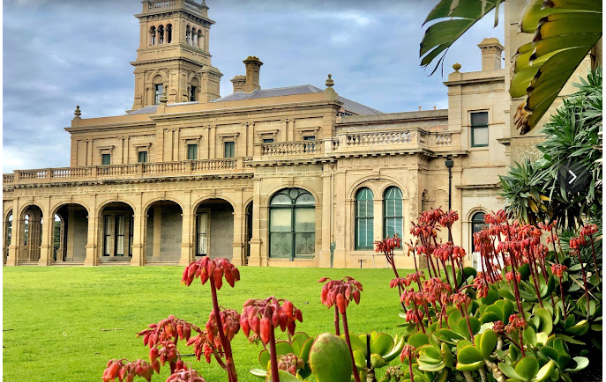

We had a lovely day at Werribee Mansion. A great day was had by all. We had a lovely meal at the Commercial Hotel in Werribee.

**Liz Triance – Coordinator**

**Eagle Arthur’s Seat – Tuesday 17 September 2024**

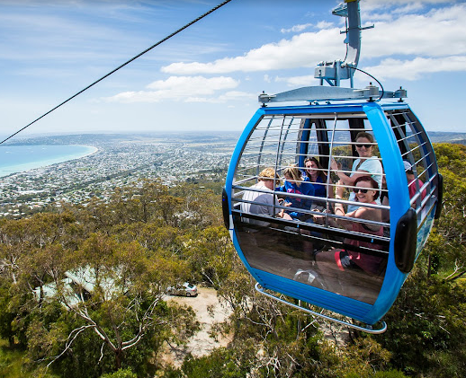

Looking forward to seeing you all on the corner of Elder Street Reserve, Greensborough on 17 September 2024 for our September outing.

Lunch will be at the Rosebud RSL

**Liz Triance**

**Mystery Trip – Tuesday 22 October 2024**



**Members $70.00**

**Non-Members $75.00**

|  |  |
| --- | --- |
| **Depart:** | 9am Corner Elder Street Reserve, Greensborough. |
| **Payment due:** | 8 October 2024  Preferably by bank transfer payment  Watsonia 50 Plus Club |
| **Direct Payment Details:** | **BSB: 633 000**  **Account No : 162498554**  **Ref: (INCLUDE YOUR NAME AND MYSTERY TRIP)** |
| **Non-Members:** | Please email your name and telephone number so we can contact you in an emergency to:  [info@watsonia50splusclub.com](mailto:info@watsonia50splusclub.com) |
| **Cash Payments:** | If paying by cash please place the cash in an envelope and place in the White Box in the Club Rooms with your Name and Mystery Trip clearly written on it |



**Northeast Victoria**

***“High Country Tour”***

The tour includes the Ovens – King – Kiewa & Buckland Valleys as well as a visit to Falls Creek Alpine Village – the scenery is just breathtaking!

**Departing Monday 18 November 2024**

**Returning Friday 22 November 2024**

**$965 per person twin share, $1205 single share.**

**A deposit of $250pp is due on Monday 23 September 2024**

**The balance is due on Monday 21 October 2024**

**$665 twin share or $905 single share**

The tour includes:

* 4 nights’ accommodation at the High-Country Motor Inn Bright. All rooms are downstairs.
* 2 course evening meals, cooked breakfast, admissions and morning teas. Lunch is not included.

A deposit of $50.00 pp is to be paid when you register your name and contact details for the trip.

A further deposit of $250.00 pp is due by Monday 23 September 2024

The balance is due Monday 21 October 2024.

Please make payment online to **BSB 633 000**

**Account No: 162 498 554. Reference your Name and North East Tour.**

EFT/POS and cash payments can be made at the Club.

Please place cash in an envelope *write your* ***name and reference –North East Trip****.*

Place envelope in our secure white box.

Cash payments can also be deposited at any Bendigo Bank Branch.

**End of year BBQ:**

To be held in the park beside the hall at 12 noon on Thursday

19 December 2024.

The Club will be closing for the Christmas holidays after the BBQ

Raffle prizes will be drawn at the BBQ

1 ticket for $2.00 or 3 tickets for $5.00



**WATSONIA RSL IN THE BISTRO**

**Christmas Lunch**

**Wednesday 11 December 2024 at 12 Noon**

**Cost per head - to be advised**

|  |  |
| --- | --- |
| **Payment Details:**  **(Preferred method of payment)** | Watsonia 50s Plus Club Inc.  BSB: 633 000. Account Number: 162498554  Reference: YOUR NAME AND CHRISTMAS LUNCH AT WATSONIA RSL |
| **Cash Payments Due:** | No later than Monday 25 November 2024. Please place your money in an envelope (with your Name and reference Watsonia RSL Christmas Lunch on it) and put in the letter box on the notice board in the Hall. |

**Proposed Day Trips in 2025:**

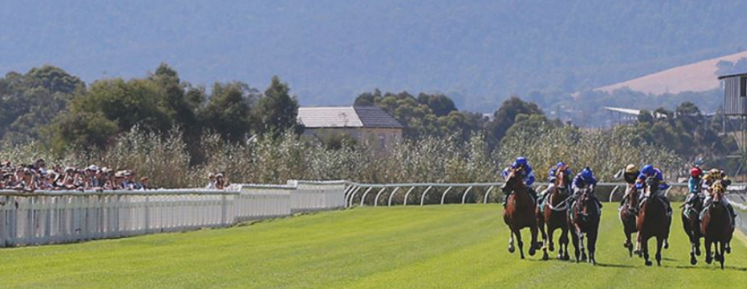**Yarra Glen Races:**

Yarra Glen Races - needs to be paid in full three weeks in advance. No refund for cancellations.

Price includes meal and a day at the races.

**Monday 31 March 2025 - $80.00 per head. Departing Delta Road at 9.15am.**

**Crown Conservatory:**

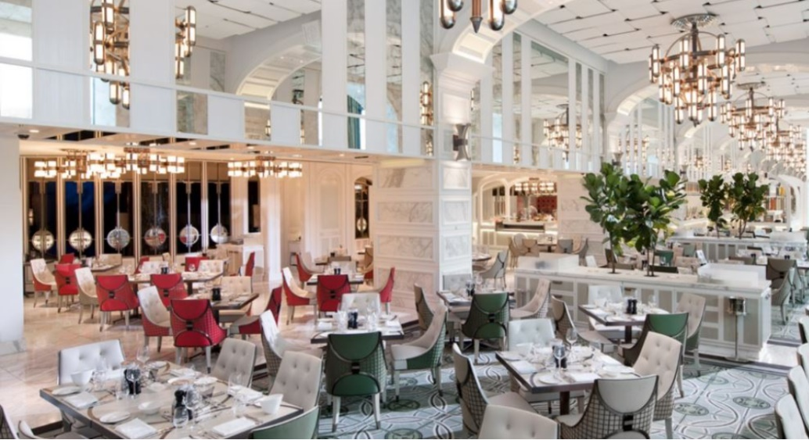

Outing to Crown Conservatory is Lunch only.

We will travel into Melbourne by train and walk to the Casino for a grand lunch.

**Tuesday 3 June 2025 - $85.00 per head. Train travel.**

*I have had a lot of interest in the above outings. I am looking for feedback from those interested in attending either the Yarra Glen Races or Crown Conservatory Lunch in 2025. Please send Liz Triance a text message if you are interested in attending either/or both of the above outings and she will return your call with updated information.*

**Liz Triance**

**Tasmania Tour 2025**

**Departing Sunday 23 November 2025 and returning 30 Sunday November 2025**

This is a 7-night coach tour to the east coast and west coast of Tasmania as well as Hobart and Launceston. We will travel by plane to and from Launceston airport.

The price is $2,760 per person or $3,250 single supplement

This price includes airfares, accommodation and transfers to and from the airport. Please refer to the itinerary attached or ask for a printed copy at the Club. It is important that you read it carefully to see what is included and consider if you need to purchase travel insurance as there is no refund after the initial deposit is made.

A deposit of $300 is required by Thursday 6th February 2025.

Please ensure that your 2025 membership is paid before this date as members will have first preference. Non-members who share with a member will be accepted.

Where possible it would be helpful if people could share accommodation as there are a limited number of rooms available.

Please contact me if you have any questions.

**Mary Ann Williams**

**Watsonia 50’s Plus Club Inc**

***Tasmania Tour***

***7 Nights $2760 per person/$3,250 single supplement***

***Price includes airfares and coach transfers to and from the Airport***

***Departing Sunday 23rd November 2025***

***Returning Sunday 30th November 2025***

***This is a fully escorted tour using the services of premier Tasmania Coach Charter Company – Redline Coaches and organised by Designer Tours Yannathan Victoria.***

***This Tasmania Discovery Tour visits both the East Coast and West Coast as well as Hobart and Launceston. Please refer to the itinerary.***

***Overnight East Coast (Scamander) – 3 nights @ Hobart – 2 nights West Coast (Queenstown) and overnight Launceston – 7 nights***

**A $300 deposit to be paid by Thursday 6 February 2025. Please ensure your 2025 Membership is paid before this date as members will have first preference.**

**Non-members who share with a member will be accepted.**

**Where possible it would be helpful if people shared accommodation as there are a limited number of rooms available.**

|  |  |
| --- | --- |
| **Payment online to BSB 633 000** | **Account No: 162 498 554** |
| **Reference your Name and Tasmania Tour** | |
|  | |

**Group Activities:**

|  |  |  |  |  |  |  |
| --- | --- | --- | --- | --- | --- | --- |
| |  |  |  |  | | --- | --- | --- | --- | |  |  |  |  |   **SCRABBLE Groups** Wednesday afternoon from 1 pm to 4 pm. We have a beginner and advanced scrabble group.  [This Photo](https://en.wikipedia.org/wiki/The_Computer_Edition_of_Scrabble) by Unknown Author is licensed under [CC BY-SA](https://creativecommons.org/licenses/by-sa/3.0/)  All welcome.  **Contact:** **Angie Winkler - 0401 810 330**  **Cards 500 & Canasta** Cards are played on three afternoons each week, Monday & Thursday 12 noon to 3.30 pm and  Saturday afternoon 1 pm to 4 pm. Beginners or long-term card  players all welcome.  **Contact:** **Lynne Kearney - 0400 154 002**  **A picture containing text, clipart  Description automatically generatedCarpet Bowls** are played every Monday & Thursday afternoon from 1pm to 3.30 pm and Saturday afternoons 1pm to 4 pm. We cater for all abilities. Beginners always welcome.  **Contact:** **Dennis Richards - 0447 575 098**  A group of people standing in a room  Description automatically generated with medium confidence  **Tai chi** is available Monday at 9 am and Thursday at 9am.  **Tai chi / qigong** class is held on Monday at 10 am.  Beginners are welcome to all classes.  **Contact: Jackie Edwards 0422 067 334**  **Aerobics for older adults**. Every Thursday at 10 am.  [This Photo](http://www.flickr.com/photos/judybaxter/5162451145/) by Unknown Author is licensed under [CC BY-SA-NC](https://creativecommons.org/licenses/by-nc-sa/3.0/)  **Gentle Aerobics** at 10.45am designed for the less active.  **Contact :** **Liz Triance 0402 047 665**  **Craft activities** – 1st and 3rd week each month commencing at 10.00am to 1200pm. Learn something new. Share your knowledge, with a “cuppa” and a chat.  **Contact : Lorraine McLellan – 0407 556 367**    **Group Activities:** |  |  |

|  |  |  |
| --- | --- | --- |
| **Table Tennis** is availableMonday and Thursday between  12-3.30pm and Saturday from 1-4pm.  **Contact : Dennis Richards 0447 575 098  Theatre Matinee Shows** usually on a Wednesday two or three times per year. Group tickets are purchased, and people arrange own transport to the theatre.  **Contact: Margaret Porritt 0409 857 884**  **Day Trips, Lunches and 1 extended trip per year.** There are several day outings each year, a Christmas in July lunch and an end of year lunch and BBQ. We have 1 extended trip each year.  **Contact :** **Liz Triance 0402 047 665** |  |  |

**Bring your own iPad/Tablet, phone or laptop.**

Please contact Mary Ann on 0412356465 or email info@watsonia50splusclub.com to give a short description of what you would like to learn and make a booking time before you attend a session.

**Contact: Mary Ann Williams 0412 356 465**

**WATSONIA 50S PLUS CLUB INC**

**MEMBERSHIP FORM 2024**

**info@watsonia50splusclub.com**

***All existing and new members please fill out each section of this form.***

**Surname:** ____________________________**First Name:** ___________________

**Address**: _______________________________________ **Postcode:** __________

**Phone:** ______________________ **Mobile:** _____________________________

**Email:** ___________________________________________________________

**Emergency Contact** (name) ___________________________________________

**Phone:** _____________________________

**Preferred Club Activity/Activities**: ______________________________________

I, __________________________ acknowledge that my participation in any Watsonia 50s Plus club activities, outings or trips are undertaken at my own risk.

**Signature:** _____________________________**Date:** ________________________

I, ________________________________________ give Watsonia 50s Plusthe authority to seek whatever medical attention is required in case of an emergency. I agree to pay the costs incurred.

**Signature:** ____________________________________**Date:** _________________

**Annual Fee: $40.00** due on 31 January 2024.

Payment available by EFT/POS at the club, online or in person at the Bendigo Bank

**Bank details: Watsonia 50s Plus Club Inc**

**BSB: 633 000 Account No: 162 498 554.**

**Reference: *your Name and Membership***

If paying online, or by EFT/POS, please email the Membership Form to the above email address or alternatively place it in the white letterbox on the white board in the Watsonia Hall.

If paying by cash place $40 and your Membership Form in an envelope in the white letter box.

|  |  |  |
| --- | --- | --- |
| **MEMBERSHIP $40.00 PER YEAR** | | |
| The Watsonia 50’s Plus Club Inc. was formed to provide social events and activities which promote health and happiness to all over 50’s who are retired or near retirement, in a non-discriminative, supportive, and appropriate environment, and live in Watsonia and its surrounding areas. | | |
| **MONDAY**  Tai Chi  Tai Chi & Qigong  Social Afternoon –  Canasta & Cards 500  Carpet Bowls | 9.00 am - 9.45 am  10.00 am - 10.45 am.  12.00pm – 3.30pm  1.00 pm – 3.30 pm | Gold coin donation  Members $4  (Non- Members $7)  Gold coin donation  Gold coin donation |
| **TUESDAY**  Bus outing | Once a month |  |
| **WEDNESDAY**  Craft  Scrabble | 10.00 am – 12.00 pm.  1.00 pm - 4.00 pm | Craft the1st & 3rd week of each month- Gold coin donation  Gold coin donation |
| **THURSDAY**  Tai Chi Aerobics  Gentle Aerobics  Social Activities –  Cards 500 / Canasta  Bowls, Table Tennis | 9.00 am - 9.45 am  10.00 am - 10.45 am  10.45 am - 11.30 am.    12.00 pm - 3.30 pm  1.00 pm – 3.30 pm | Gold coin donation Members $6 (Non-Members $8)  Members $6 (Non-Members $8)  Gold coin donation  Gold coin donation |
| **SATURDAY**  Carpet Bowls, Cards 500  Canasta | 1.00pm - 4.00pm | Gold coin donation  Gold coin donation |
| **SUNDAY –**  **20 October 2024**  Old Time Dance  Bundoora Community Hall  20 Noorong Avenue  Bundoora | 1.30pm - 5.00pm | $5 per head |

